16.34: We are to assume If 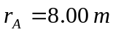 and 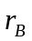 are the distances of the person from each speaker, the condition for destructive interference is 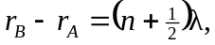 where n is any integer. Requiring 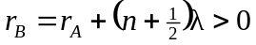 gives so the smallest value of occurs when 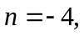and the closest distance to B is

